**Assignment**

**Usage of CAT Command:**

If you have worked in Linux, you surely have seen a code snippet that uses the cat command. Cat is short for concatenate. This command displays the content of one or more files without having to open the file for editing.

**Cat Command Syntax:**

Before going into how to use the cat command, let’s start by reviewing the basic syntax.

Cat [OPTIONS] [FILE_NAMES]

OPTIONS - cat options.

FILE_NAMES - Zero or more file names.

**Examples of CAT Command:**

1. Display Contents of File:

**# cat /etc/passwd**

It will shows the content of /etc/passwd file.

1. View Contents of Multiple Files in terminal

**# cat test test1**

Display the contents of test and test1 file in terminal.

1. Create a file with Cat Command

**# cat >test2**

Create a file called test2.

Type desired text and press CTRL+D to exit. The text will be written in

Test2file. You can see content of file with following cat command.

**# cat test2**

1. Display Line Numbers in File

**# cat -n song.txt**

With –n option you could see the line numbers of a file song.txt in the output terminal.

1. Display Multiple Files at Once

**# cat test; cat test1; cat test2**

We have three files test, test1, test2 and able to view the contents of those files. We need to separate each file with ; (semicolon).

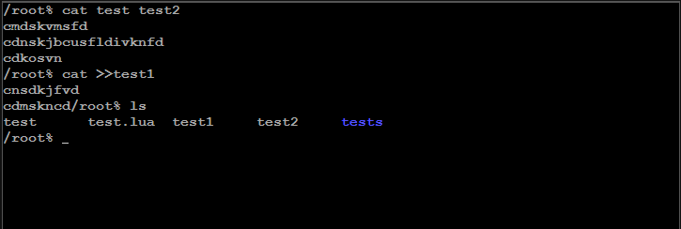

**Usage of GREP Command:**

The grep Comand is used to search text or searches the given file for lines containing a match to the given strings or words. By default, grep displays the matching lines. Use grep to search for lines of text that match one or many regular expressions, and outputs only the matching lines.

**Grep Command Syntax:**

Grep “string” file name

**Examples of GREP Command:**

1. Search a file for Specific Word

**grep failure /var/log/secure**

This is really one of the most elementary uses for grep. Let's say I want to inspect the contents of the /var/log/secure log for any instances of a failure.

1. **Search a file for Multiple words**

**grep 'opened\|closed' /var/log/secure**

This command permits you to check for multiple words in a file - note the use of the single quotes, the backslash and the pipe command between them

1. Get an instance Count

**grep failure /var/log/secure –c**

You may not want to actually see the output of the grep command but have it tell you how many matches your search found. This is performed using the -c (count) switch

1. **Display the line numbers of each match**

**grep -n failure /var/log/secure**

It can be helpful to know which line number your search results appear on. To do so, add the -n (number) switch

1. Return only Specific number of matches

**grep -m5 failure /var/log/secure**

Let's say I want to only see the first five search results. I can narrow these down using the -m (maximum count) switch.

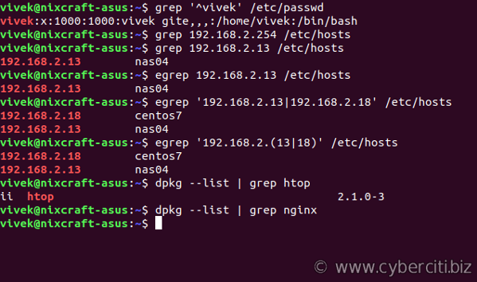

**Linux PWD Command:**

Linux pwd (print working directory) command displays your location currently you are working on. It will give the whole path starting from the root ending to the directory.

**Syntax:**

Pwd

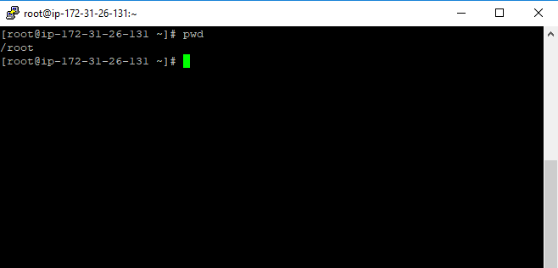

**Linux ls Command**

The **ls** is the list command in Linux. It will show the full list or content of your directory. Just type ls and press the enter key. The whole content will be shown**.**

**Syntax:**

Ls

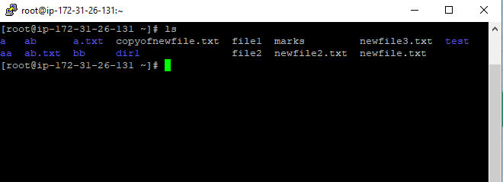

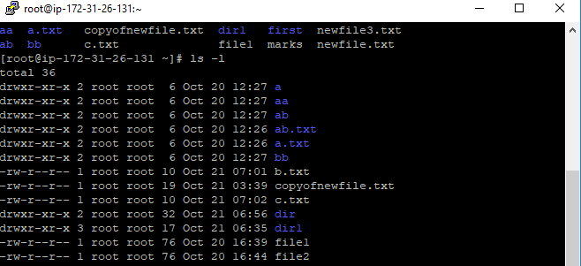

**Linux cd Command**

Linux **cd** command is used to change the current working directory ( i.e., in which the current user is working). The "cd" stands for **'change directory**.' It is one of the most frequently used commands in the Linux terminal.

**Syntax:**

cd <dirname>

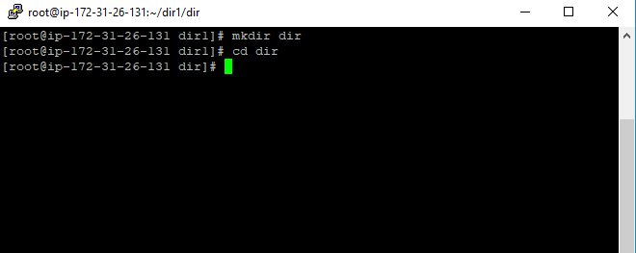

**Linux mkdir & rmdir Command**

The mkdir stands for 'make directory'. With the help of mkdir command, you can create a new directory wherever you want in your system. Just type **"mkdir <dir name>** , in place of <dir name> type the name of new directory, you want to create and then press enter.

**Syntax:**

mkdir <dirname>

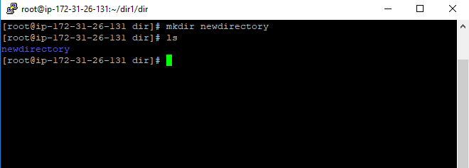

This command is used to delete a directory. But will not be able to delete a directory including a sub-directory. It means, a directory has to be empty to be deleted.

**Syntax:**

rmdir <dirname>

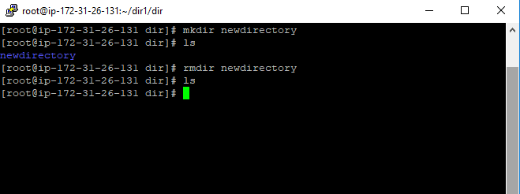

**Linux rm Command**

The 'rm' means remove. This command is used to remove a file. The command line doesn't have a recycle bin or trash unlike other GUI's to recover the files. Hence, be very much careful while using this command.

**Syntax:**

rm <filename>

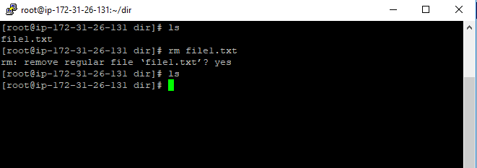

**Linux Touch Command**

touch command is a way to create empty files (there are some other mehtods also). You can update the modification and access time of each file with the help of touch command.

**Syntax:**

touch <filename>

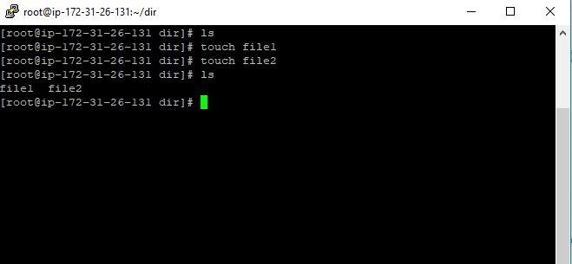

**Linux man & --help Command**

The "man" is a short term for manual page. In unix like operating systems such as linux, man is an interface to view the system's reference manual.

A user can request to display a man page by simply typing man followed by a space and then argument. Here its argument can be a command, utility or function. A manual page associated with each of these arguments is displayed.

**Syntax:**

man [option(s)] keyword(s)



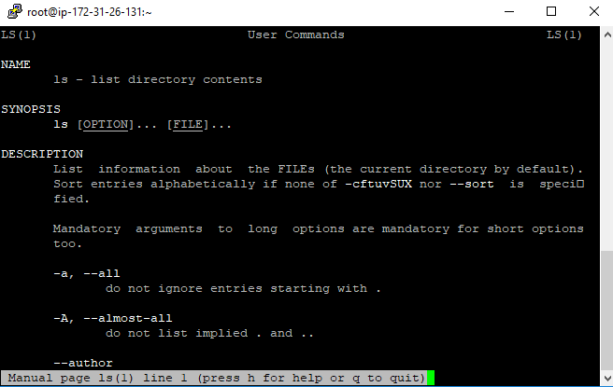

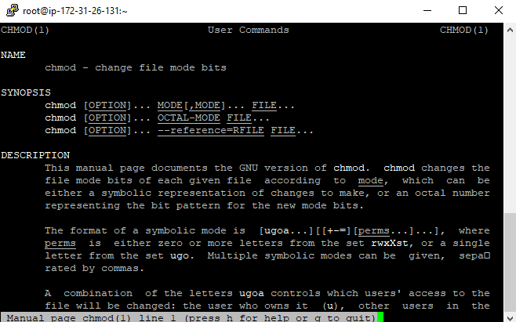

The **help** command is a shell built-in internal command. It accepts a text string as the command line argument and searches the supplied string in the shell's documents. If the supplied string matches with an internal command, the **help** command picks the available information about that command from the shell's document and displays that information on the terminal.

**Syntax:**

$help [options] [text-string/pattern/internal-command]



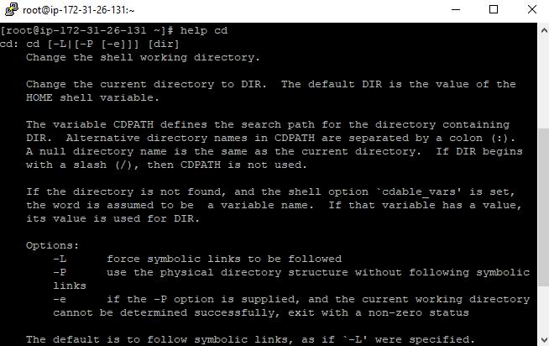

**Linux cp Command**

cp' means copy. 'cp' command is used to copy a file or a directory

**Syntax:**

cp **<existing** file name**>** **<new** file name**>**

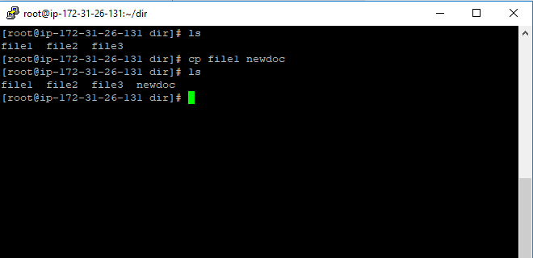

**Linux mv Command**

Linux mv command is used to move existing file or directory from one location to another. It is also used to rename a file or directory. If you want to rename a single directory or file then **'mv'** option will be better to use.

**Syntax:**

**mv <option> <source> <destination>**

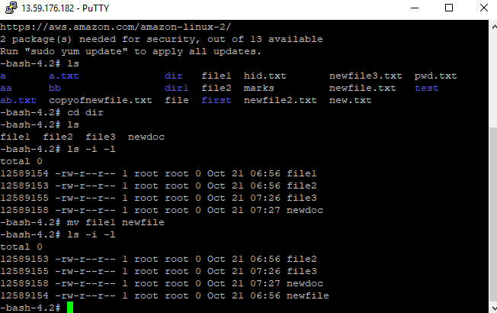

**Linux Locate Command**

The locate command and [find](https://www.javatpoint.com/linux-find)command is used to search a file by name. But, the difference between both commands is that locate command is a background process and searches the file in the database whereas, find command searches in the filesystem. The locate command is much faster than find command.

**Syntax:**

locate [OPTION]... PATTERN...

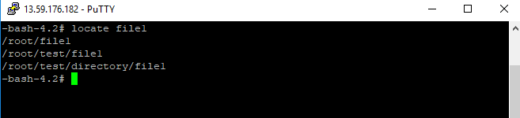

**Linux echo Command**

**echo** command in linux is used to display line of text/string that are passed as an argument . This is a built in command that is mostly used in shell scripts and batch files to output status text to the screen or a file.

Syntax:

echo [option] [string]

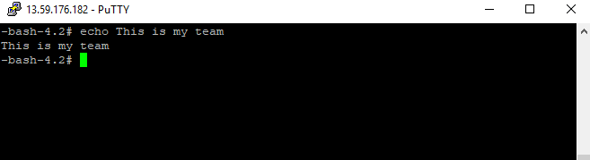

**Linux Text Editors**

Linux text editors can be used for **editing text files, writing codes, updating user instruction files,** and more. A Linux system supports multiple text editors.

There are two types of text editors in Linux, which are given below:

* **Command-line text editors** such as Vi, nano, pico, and more.
* **GUI text editors** such as gedit (for Gnome), Kwrite, and more.

A text editor plays an important role while coding. So, it is important to select the best text editor. A text editor should not only be simple but also functional and should be good to work with.

1. Vi/VIm Editor:

Vim editor is one of the most used and powerful command-line based editor of the Linux system.

It is a user-friendly editor and provides the same environment for all the Linux distros.

It is also termed as **programmer's editor** because most programmers prefer Vi editor.

Vi editor has some special features such as Vi modes and syntax highlighting that makes it powerful than other text editors. Generally, it has two modes:

**Command Mode:** The command mode allows us to perform actions on files. By default, it starts in command mode. In this mode, all types of words are considered as commands. We can execute commands in this mode.

**Insert Mode:** The insert mode allows to insert text on files. To switch from command mode to insert mode, press the **Esc** key to exit from active mode and **'i'** key.

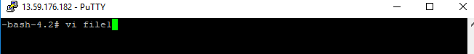

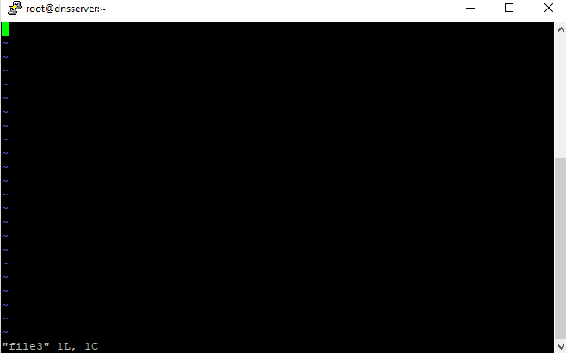

1. Nano Editor

Nano is a straight forward editor. It is designed for both beginners and advanced users. It has many customization features.

Some advanced features of a nano text editor are as following:

* It has highly customizable key bindings
* It supports syntax highlighting
* It has undo and redo options
* It provides full line display on the standard output
* It has pager support to read from standard input

**Syntax:**

namo <filename>

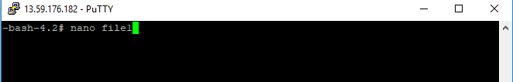

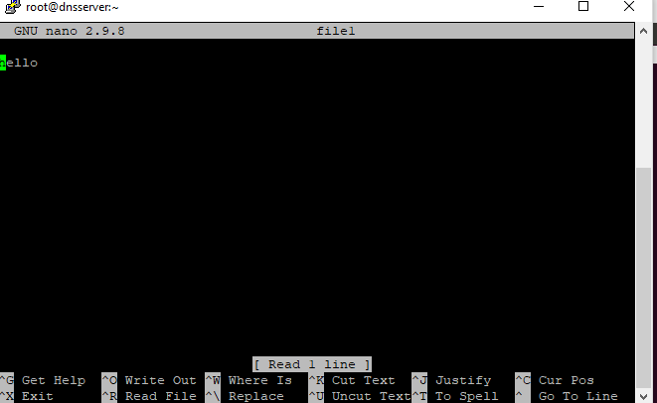

1. Linux jed Editor

The Jed is a command-line editor that supports extensive use of the S-Lang library. Jed supports its all flavors for different operating systems such as Linux and Windows. It is a lightweight editor, which makes it an ideal editor for the low configuration systems.

Some key features of Jed editor are as following:

* It provides color syntax highlighting on color terminals.
* It has code folding support.
* It provides drop-down menus on the terminal.
* It has the support of emulates editors such as Emacs, EDT, WordStar, Borland, Brief, etc.
* It is extensible in the C-like language S-Lang to make it highly customizable.
* It supports a variety of programming modes for multiple programming languages.

To install the Jed editor, execute the following commands:

sudo apt-get update -y

sudo apt-get install -y jed

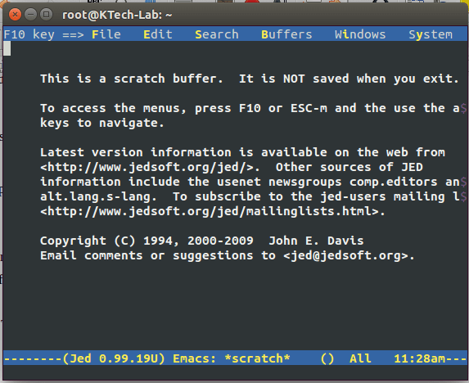

**Linux Sudo Command**

Sudo stands for SuperUser DO and is used to access restricted files and operations. By default, Linux restricts access to certain parts of the system preventing sensitive files from being compromised. The sudo command temporarily elevates privileges allowing users to complete sensitive tasks without logging in as the root user.

Syntax:

sudo -V | -h | -l | -v | -k | -K | -s | [ -H ] [-P ] [-S ] [ -b ] |  
[ -p prompt ] [ -c class|- ] [ -a auth_type ] [-r role ] [-t type ]  
[ -u username|#uid ] commandsudo -V | -h | -l | -L | -v | -k | -K | -s | [ -H ] [-P ] [-S ] [ -b ] |  
[ -p prompt ] [ -c class|- ] [ -a auth_type ] [-r role ] [-t type ]  
[ -u username|#uid ] command

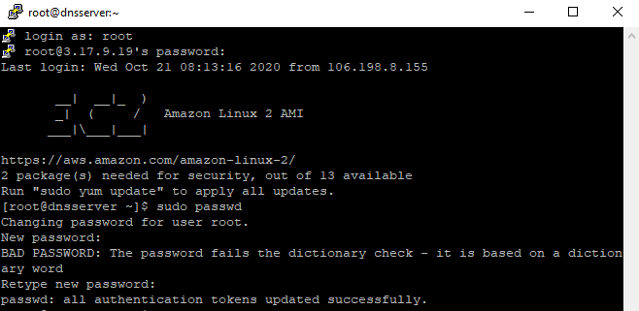

**Linux df Command**

Linux df command is used to display the **disk space used in the file system**. The 'df' stands for **"disk filesystem**." It defines the number of blocks used, the number of blocks available, and the directory where the file system is mounted.

Syntax:

df [OPTION]... [FILE]...

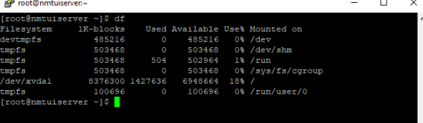

**Linux du Command**

Command du stands for **D**isk **U**sage. It is used to check the information of disk usage of files and directories on a system.

Command du display a list of all the files along with their respective sizes. By default, size given is in kilobytes.

File names are used as arguments to get the file size.

Syntax:

du

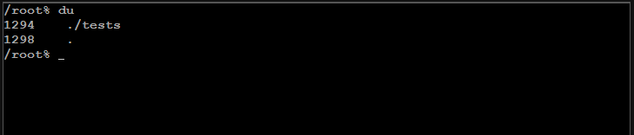

**Linux tar Command**

The tar command stands for tape achieve, which is the most commonly used tape drive backup command used by the Linux/Unix system.  It allows for you to quickly access a collection of files and placed them into a highly compressed archive file commonly called tarball, or tar, gzip, and bzip in Linux. The algorithm used for compressing of .tar.gz and .tar.bz2 are gzip or bzip algorithms respectively.

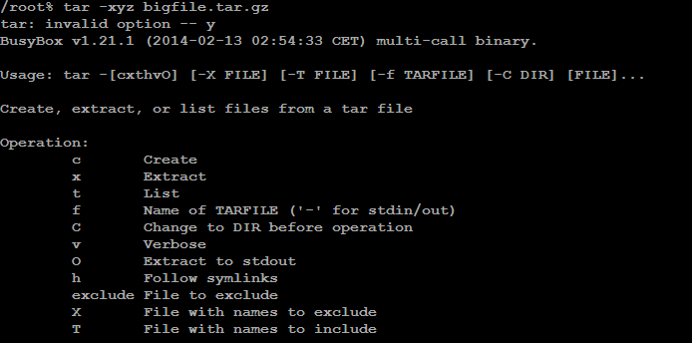

**Linux zip, unzip Command**

We touch base on the **zip** and **unzip** **commands** and how they are used in Linux. Zip is a command used for creating an archive file or a zipped file. This allows you to compress your files and create more space for other files on your hard drive or removable drive. Additionally, zipping your files/directories makes them more portable and easier to upload, download or even attach and send them via email.The opposite of zipping is unzipping, and here we use the unzip command to decompress the files and access them individually.

Syntax:

 zip OPTIONS archive.zip file

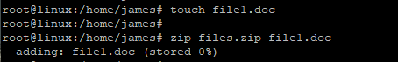

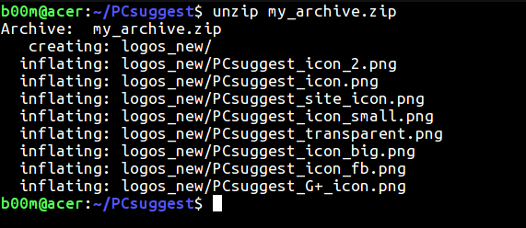

**Linux uname Command**

The command ‘uname‘ displays the information about the system.

Syntax:

Uname [option]

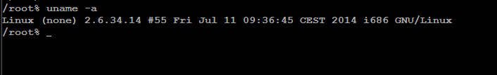

**Linux apt-get Command**

On [Linux](https://www.computerhope.com/jargon/l/linux.htm) [operating systems](https://www.computerhope.com/jargon/o/os.htm) that use the [APT](https://www.computerhope.com/jargon/a/apt.htm) package management system, the **apt-get** command is used to install, remove, and perform other operations on installed software [packages](https://www.computerhope.com/jargon/p/package.htm).

Syntax:

pt-get [-asqdyfmubV] [-o=*config_string*] [-c=*config_file*] [-t=*target_release*]

[-a=*architecture*] {update | upgrade | dselect-upgrade | dist-upgrade |

install *pkg* [{=*pkg_version_number* | /*target_release*}]... |

remove *pkg*... | purge *pkg*... |

source *pkg* [{=*pkg_version_number* | /*target_release*}]... |

build-dep *pkg* [{=*pkg_version_number* | /*target_release*}]... |

download *pkg* [{=*pkg_version_number* | /*target_release*}]... |

check | clean | autoclean | autoremove | {-v | --version} |

{-h | --*help*}}

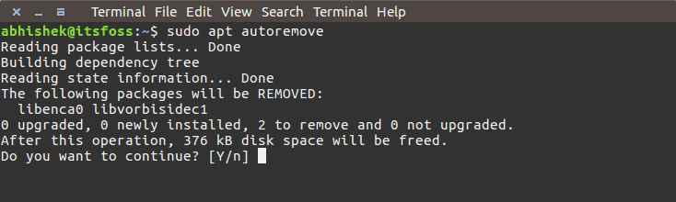

**Linux chmod Command**

In Unix-like operating systems, the **chmod** command is used to change the access mode of a file.  
The name is an abbreviation of **change mode**.

Syntax:

chmode [reference][operator][mode] files…

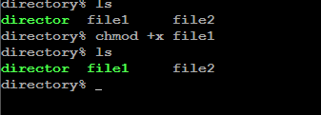

**Linux hostname Command**

hostname command in Linux is used to obtain the DNS(Domain Name System) name and set the system’s hostname or NIS(Network Information System) domain name. A hostname is a name which is given to a computer and it attached to the network. Its main purpose is to uniquely identify over a network.

Syntax:

hostname –[option][file]

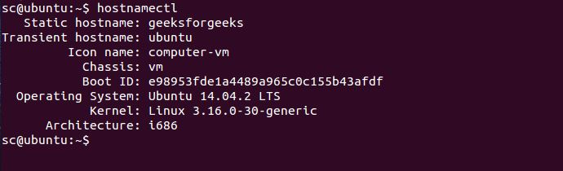

**Linux ping Command**

PING (Packet Internet Groper) command is used to check the network connectivity between host and server/host. This command takes as input the IP address or the URL and sends a data packet to the specified address with the message “PING” and get a response from the server/host this time is recorded which is called latency. Fast ping low latency means faster connection. Ping uses [**ICMP(Internet Control Message Protocol)**](https://www.geeksforgeeks.org/internet-control-message-protocol-icmp/) to send an **ICMP echo message** to the specified host if that host is available then it sends **ICMP reply message**.

Syntax:

ping [filename]

